ACTIVITY 1
M.Arshini (192424322)
- Draw a pie chart representation of the distribution of spending in a household budget and what is the weighted average category of spending in a household budget based on the following pie chart distribution?
Housing: 40%
Transportation: 20%
Food: 30%
Entertainment: 10%

OUTPUT:
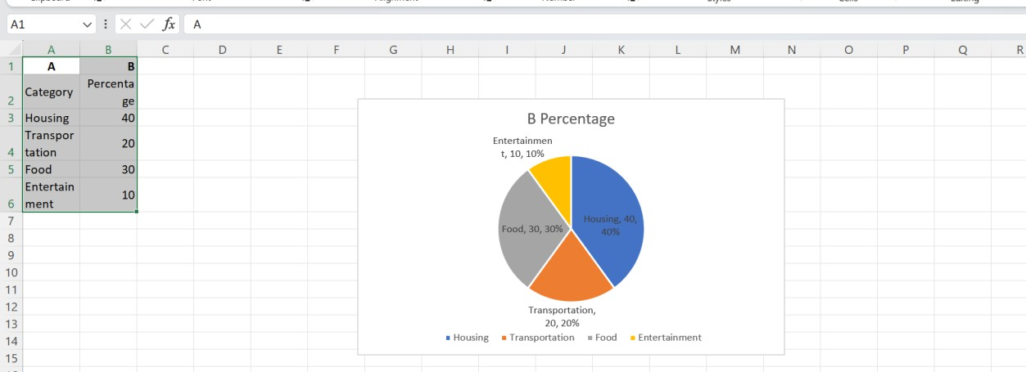
- A: 90-100
B: 80-89
C: 70-79
D: 60-69
E: Below 60
In a class of 30 students, describe the above details with the bar chart. What was the average score of the class on this test?

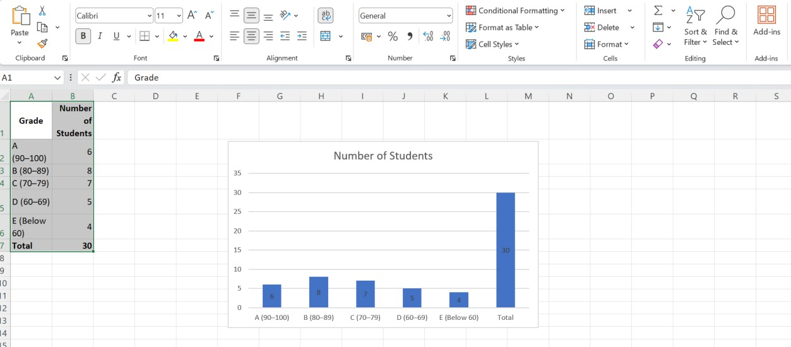
OUTPUT:

- If the survey participants were asked to choose only one fruit as their favourite, which fruit was the most preferred among them and find the low preferred fruit with the bar chart.

OUTPUT:
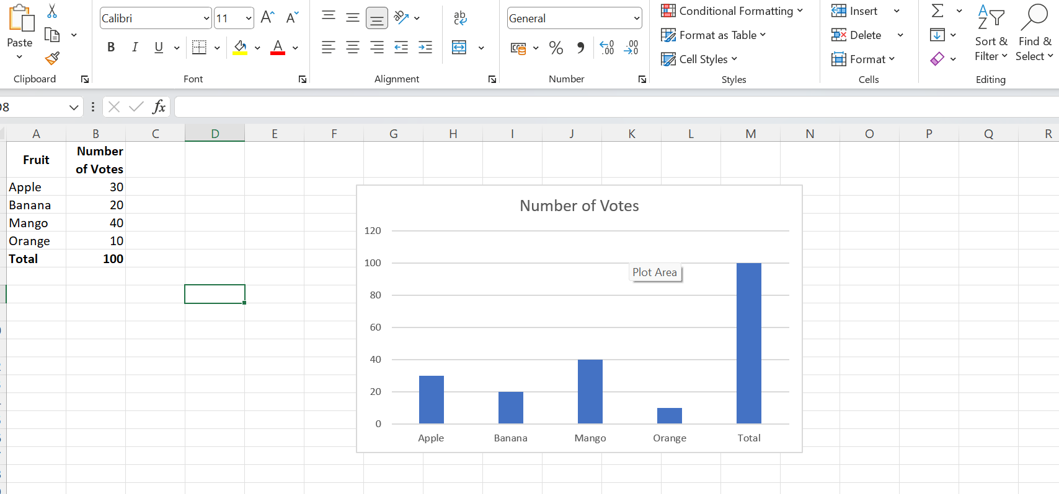
- If there are 200 employees in total, how many employees are likely to work in the Marketing department based on the pie chart?

OUTPUT:

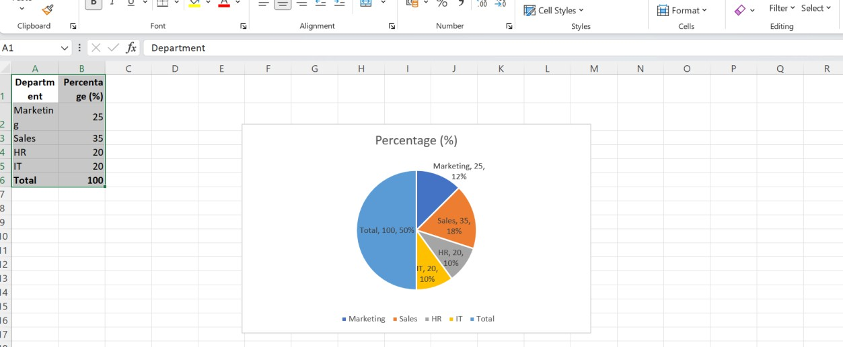
- A company conducted a survey to find out how its employees spend their free time during the weekends. The results were represented in the form of a pie chart as follows:
Video games: 20%
Reading – 35%
Cooking – 20%
Painting – 10%
Music Listening – 25%
According to the pie chart, what is the most common activity among the company's employees during the weekends?

OUTPUT:
